**VISVESVARAYA TECHNOLOGICAL UNIVERSITY**

**BELAGAVI**



***Project Based Learning Report on***

# *“*Obstacle Avoiding Robot”

*Submitted in the partial fulfillment for the requirements of the degree of*

Data Communication - 17CS46, Microprocessors and Microcontrollers - 17CS44

*Submitted By*

**ANUJ V** USN: 1BY17CS028

**JANANI A** USN: 1BY17CS069

**K HARSHITHA** USN: 1BY17CS071

**KAVYA L K**  USN: 1BY17CS079

**JAISON SAJI** USN: 1BY17CS199

*Under the guidance of*

*Dr. Anil G N Dr. Anupama H S*



DEPARTMENT OF COMPUTER SCIENCE AND ENGINEERING

BMS INSTITUTE OF TECHNOLOGY & MANAGEMENT

YELAHANKA, BENGALURU - 560064.

2018-2019

**VISVESVARAYA TECHNOLOGICAL UNIVERSITY**

**BELAGAVI**

**BMS INSTITUTE OF TECHNOLOGY &MANAGEMENT**

**YELAHANKA, BENGALURU – 560064**

**DEPARTMENT OF COMPUTER SCIENCE AND ENGINEERING**



**CERTIFICATE**

# This is to certify that the Project work entitled*“*Obstacle Avoiding Robot”

is a bonafide work carried out by ANUJ V (1BY17CS028) JANANI A (1BY17CS069 )K HARSHITHA (1BY17CS071) KAVYA L K (1BY17CS079) JAISON SAJI (1BY17CS199 )in partial fulfillment for **Data Communication - 17CS46, Microprocessors andMicrocontrollers - 17CS44** during the year 2018-2019. It is certified that all corrections/suggestions indicated for Internal Assessment have been incorporated in this report. The project report has been approved as it satisfies the academic requirements inrespect of project work for DC and MP.

**Signature of the Guide Signature of the HOD** Dr.Anupama H S Dr. ANIL G N

Associate Professor, Professor & HOD,

Dept. of CSE, Dept. of CSE BMSIT&M BMSIT&M

**INSTITUTE VISION**

To emerge as one of the finest technical institutions of higher learning, to develop engineering professionals who are technically competent, ethical and environment friendly for betterment of the society.

**INSTITUTE MISSION**

Accomplish stimulating learning environment through high quality academic instruction, innovation and industry-institute interface.

**DEPARTMENT VISION**

To develop technical professionals acquainted with recent trends and technologies of computer science to serve as valuable resource for the nation/society.

**DEPARTMENT MISSION**

Facilitating and exposing the students to various learning opportunities through dedicated academic teaching, guidance and monitoring.

**PROGRAM EDUCATIONAL OBJECTIVES**

1. Lead a successful career by designing, analysing and solving various problems in the field of Computer Science & Engineering.
2. Pursue higher studies for enduring edification.
3. Exhibit professional and team building attitude along with effective communication.
4. Identify and provide solutions for sustainable environmental development.

**ACKNOWLEDGEMENT**

We are happy to present this project after completing it successfully. This project would not have been possible without the guidance, assistance and suggestions of many individuals. We wouldlike to express our deep sense of gratitude and indebtedness to each and every one who hashelped us make this project a success.

We heartily thank our Principal, Dr. MOHAN BABU G N, BMS Institute of Technology &Management, for his constant encouragement and inspiration in taking up this project.

We heartily thank our Professor and Head of the Department, Dr. Anil G N,Department of Computer Science and Engineering, BMS Institute of Technology &Management, for his constant support in doing this project.

We gracefully thank our Project Guide, Dr. Anupama H S, Associate Professor, and Dr. Anil G N Professor and HOD, Department of Computer Science and Engineering for his intangible support for our project.

Special thanks to all the staff members of Computer Science Department for their help and kind co-operation.

Lastly we thank our parents and friends for their support and encouragement given tous in completing this precious work successfully.

**ANUJ V (**1BY17CS028 )

**JANANI A (**1BY17CS069)

**K HARSHITHA (**1BY17CS071)

**KAVYA L K**  (1BY17CS079)

**JAISON SAJI (**1BY17CS199 )

**ABSTRACT**

The project is design to build an obstacle avoidance robotic vehicle using ultrasonic sensors for its movement. A micro-controller (AT mega 8) is used to achieve the desired operation. A robot is a machine that can perform task automatically or with guidance. Robotics is a combination of computational intelligence and physical machines (motors). Computational intelligence involves the programmed instructions. The project proposes robotic vehicle that has an intelligence built in it such that it directs itself whenever an obstacle comes in its path. This robotic vehicle is built, using a micro-controller of AT mega 8 family. An ultrasonic sensor is used to detect any obstacle ahead of it and sends a command to the microcontroller. Depending on the input signal received, the micro-controller redirects the robot to move in an alternate direction by actuating the motors which are interfaced to it through a motor driver.

|  |  |
| --- | --- |
| **Course Outcomes (COs)** | |
| **CO6** | *Develop useful applications illustrating the concepts learnt using OpenGL. (K6)* |

**Project to Program Outcomes (PO) Mapping**

**Project Name:** OBSTACLE AVOIDANCE ROBOT

|  |  |  |  |  |  |  |  |  |  |  |  |
| --- | --- | --- | --- | --- | --- | --- | --- | --- | --- | --- | --- |
| **PO1** | **PO2** | **PO3** | **PO4** | **PO5** | **PO6** | **PO7** | **PO8** | **PO9** | **PO10** | **PO11** | **PO12** |
| ✓ | ✓ | ✓ | ✓ | ✓ |  |  | ✓ | ✓ | ✓ | ✓ | ✓ |

|  |  |
| --- | --- |
| **Program outcomes (POs):** | |
| **PO1** | **Engineering knowledge:** Apply the knowledge of Mathematics, Science, Engineering fundamentals and an engineering specialization to the solution of complex engineering problems |
| **PO2** | **Problem analysis:** Identify, formulate, review research literature, and analyse complex Engineering problems reaching substantiated conclusions using first principles of mathematics, Natural sciences and engineering sciences |
| **PO3** | **Design/development of solutions:** Design solutions for complex engineering problems and design system components or processes that meet the specified needs with appropriate consideration for the public health and safety, and the cultural, societal, and environmental considerations. |
| **PO4** | **Conduct investigations of complex problems**: Use research-based knowledge and research methods including design of experiments, analysis and interpretation of data, and synthesis of the Information to provide valid conclusions |
| **PO5** | **Modern tool usage**: Create, select, and apply appropriate techniques, resources, and modern Engineering and IT tools including prediction and modelling to complex engineering activities with an understanding of the limitations. |
| **PO6** | **The engineer and society:** Apply reasoning informed by the contextual knowledge to assess societal, health, safety, legal and cultural issues and the consequent responsibilities relevant to the professional engineering practice. |
| **PO7** | **Environment and sustainability:** Understand the impact of the professional engineering solutions in societal and environmental contexts, and demonstrate the knowledge of, and need for Sustainable development |
| **PO8** | **Ethics:** Apply ethical principles and commit to professional ethics and responsibilities and norms of the engineering practice. |
| **PO9** | **Individual and team work:** Function effectively as an individual, and as a member or leader in diverse teams, and in multidisciplinary settings |
| **PO10** | **Communication:** Communicate effectively on complex engineering activities with the engineering Community and with society at large, such as, being able to comprehend and write effective reports And design documentation, make effective presentations, and give and receive clear instructions. |
| **PO11** | **Project management and finance:** Demonstrate knowledge and understanding of the Engineering and management principles and apply these to one’s own work, as a member and Leader in a team, to manage projects and in multidisciplinary environments. |
| **PO12** | **Life-long learning:** Recognize the need for, and have the preparation and ability to engage in independent and life-long learning in the broadest context of technological change. |

**Project to Program Specific Outcomes (PSO) Mapping**

**Project Name:** OBSTACLE AVOIDANCE ROBOT

|  |  |
| --- | --- |
| **PSO1** | **PSO2** |
| ✓ | ✓ |

|  |  |
| --- | --- |
| **Program Specific Outcomes (PSOs):** | |
| **PSO1** | Analyze the problem and identify computing requirements appropriate to its solution. |
| **PSO2** | Apply design and development principles in the construction of software systems of varying complexity. |

**TABLE OF CONTENTS**

1. ACKNOWLEDGEMENT

2. ABSTRACT

3. TABLE OF CONTENTS

CHAPTER NO. TITLE PAGE NO

CHAPTER 1 INTRODUCTION 01

1.1 BriefIntroduction 01

1.2 Motivation 01

1.3 Scope 02

1.4 Problem Statement 02

1.5 Proposed System 02

1.6 Limitations 02

CHAPTER 2 SYSTEM REQUIREMENT 03

CHATER 3 ALGORITHM 04

CHAPTER 4 SYSTEM ANALYSIS 05

CHAPTER 5 IMPLEMENTATION 07

CHAPTER 6 INTERPRETATION OF RESULTS 11

CONCLUSION 12

FUTURE ENHANCEMENTS 12

BIBLIOGRAPHY 12

**1 INTRODUCTION**

**1.1 Brief Introduction:**

Obstacle avoidance is a primary requirement of any autonomous mobile robot. Obstacle avoidance Robot is design to allow robot to navigate in unknown environment by avoiding collisions. Obstacle avoiding robot senses obstacles in the path, avoid it and resumes its running. There are some very famous methods for robot navigation like wall-following, edge detection, line following. One of the commercial systems uses wall following method on a floor cleaning robot for long hallways. A more general and commonly employed method for obstacle avoidance is based on edge detection. A disadvantage with obstacle avoidance based on edge detecting is the need of the robot to stop in front of an obstacle in order to provide a more accurate measurement. All mobile robots feature some kind of collision avoidance, ranging from primitive algorithms that detect an obstacle and stop the robot in order to avoid a collision, using some sophisticated algorithms, that enable the robot to detour obstacles. The latter algorithms are more complex, since they involve detection of an obstacle as well as some kind of quantitative measurements concerning the obstacle's dimensions. Once these have been determined, the obstacle avoidance algorithm needs to steer the robot around the obstacle and resume motion toward the original target. In this paper the steering algorithm ensures that the robot does not have to stop in front of an obstacle during its navigation. Hence the robots may overcome some of the problems during navigation, which are discussed above and it can navigate smoothly during its operation avoiding the collisions. We have presented a basic algorithm and design which can be further improved depending upon the required applications.

**1.2MOTIVATION**

Autonomous navigation of robots in real life complex domains is an interesting and constructive task to accomplish. In order to do this the robot should be able to perceive the relative depths of various objects, dynamic or stationary, in its field of view.

**1.3 SCOPE**

In simple robot, steering algorithm is used for robotic actions in which driver or a human being is controlling the robot using remote. Here driver is present, who can see the obstacle and navigate robot accordingly.

**1.6 PROBLEM STATEMENT**

The objective is to create a robot, which avoids obstacles present in its course. This is done with the help of an ultrasonic sensor, which sends ultrasonic rays, and ‘if’ in the case of an obstacle; the rays bounce back. Accordingly, the robot reroutes its course.

This moves forward with the vision of automated driving, obstacle detecting for military purposes.

**1.5 PROPOSED SYSTEM**

The project proposes an autonomous robotic vehicle, in which no remote is used for controlling the robotic actions. It intelligently detects obstacles present on its path through the sensors, avoid it and take decision on the basis of internal code that we set for it.

The detail information is given in the following subtopics which will help you to understand the whole system and its design.

**1.7 LIMITATIONS**

If there is an obstacle behind the robot it would not be able to detect the object as there is no sensor at the back we can improve this by adding a sensor at the back of the robot.

**2. SYSTEM REQUIREMENTS**

* Operating system:

Windows 10/XP/Vista/7/8/8.1

* Software:

Open-source Arduino software (IDE)

* An ultrasonic sensor
* Arduino Uno Microcontroller
* 4x DC Motor
* Motor Driver Module

**3.ALGORITHM**

The sonar system is used in HC-SR04 ultrasonic sensor to determine distance to an object like bats do. It offers excellent non-contact range detection from about 2 cm to 400 cm or 1’’ to 13 feet. Its operation is not affected by sunlight or black material.

The ultrasonic sensor emits the short and high frequency signal. If they detect any object, then they reflect back echo signal which taken as input to the sensor through Echo pin.

First we initialize Trigger and Echo pin as low and push the robot in forward direction. when obstacle is detected Echo pin will give input as high to microcontroller. pulseIn() function is used for calculating the time of distance from the obstacle. Every time the function waits for pin to go high and starts timing, then timing will be stopped when pin go to low. It returns the pulse length in microseconds or when complete pulse was not received within the timeout it returns

The timing has been determined means it gives length of the pulse and will show errors in shorter pulses. Pulses from 10microseconds to 3 minutes in length are taken into consideration.

After determining the time, it converts into a distance. If the distance of object is moderate then speed of robot gets reduced and will take left turn, if obstacle is present in left side then it will take right turn.

If the distance of object is short then speed of robot gets reduced and will turn in backward direction and then can go in left or right direction.

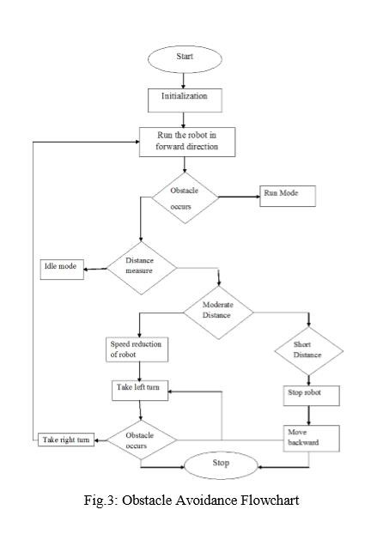

**3.SYSTEM ANALYSIS**

**BASIC DESIGN OF ROBOT:**

This robot was built with an Arduino development board on which microcontroller is placed. Arduino board is connected with DC Motor through Motor driver board (pin10, pin11, pin12, pin13) which provide power to the actuators. Actuators are used to move robot in Forward, Backward, Left and Right directions. The brief description of inputs pins for movement of robot is given in below in table.

Movement Pin 10 Pin 11 Pin 12 Pin 13

Forward 1 0 0 1 Backward 0 1 1 0 Left 1 0 1 0 Right 0 1 0 1 The movement of robot will be stop whenever there is an obstacle is present on its path which can be detected by ultrasonic sensors. Ultrasonic sensors give time in length to the microcontroller as input for further actions.

**SENSORS FOR OBSTACLE AVOIDANCE:**

Varieties of sensors are available which can be used for the detection of obstacles. Some of the very popular sensors are: Infrared sensors (IR),Ultrasonic sensors, Cameras, which can be used as a part of Computer Vision, Sonar. It can measure the distance in its field of view of about thousands to hundreds points in the design of robot, we are using ultrasonic sensors for obstacle detection and avoidance. The ultrasonic sensors continuously emits the frequency signals, when obstacle is detected this signals are reflected back which then considered as input to the sensor.

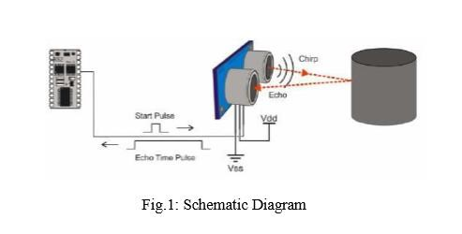

The ultrasonic sensor consists of a multi vibrator, which fixed at its base. The multi vibrator is combination of a resonator and vibrator. The ultrasonic waves generated by the vibration are delivers to the resonator. Ultrasonic sensor actually consists of two parts: the emitter which produces a 40 kHz sound wave and detector which detects 40 kHz sound wave and sends electrical signal back to the microcontroller.

In our project, we are using HC-SR04 ultrasonic sensors which consist of 4 pins VCC, Trigger, Echo and GND.

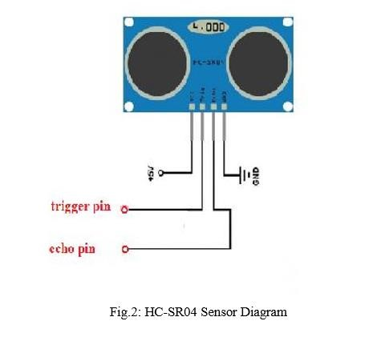

Features:

Power Supply: +5V DC

Working Current: 15mA

Effectual Angle: <15degree

Ranging Distance: 2cm –400cm/1’’- 13ft

Resolution: 0.3cm

Measuring Angle: 30 degree

Input pulse width: 10uS

**4.IMPLEMENTATION**

#include <AFMotor.h>

#include <NewPing.h>

#include <Servo.h>

#define TRIG_PIN A0

#define ECHO_PIN A1

#define MAX_DISTANCE 200

#define MAX_SPEED 190 // sets speed of DC motors

#define MAX_SPEED_OFFSET 20

NewPingsonar(TRIG_PIN, ECHO_PIN, MAX_DISTANCE);

AF_DCMotor motor1(1, MOTOR12_1KHZ);

AF_DCMotor motor2(2, MOTOR12_1KHZ);

AF_DCMotor motor3(3, MOTOR34_1KHZ);

AF_DCMotor motor4(4, MOTOR34_1KHZ);

Servo myservo;

booleangoesForward=false;

int distance = 100;

int speedSet = 0;

void setup() {

myservo.attach(10);

myservo.write(115);

delay(2000);

distance = readPing();

delay(100);

distance = readPing();

delay(100);

distance = readPing();

delay(100);

distance = readPing();

delay(100);

}

void loop() {

int distanceR = 0;

int distanceL= 0;

delay(40);

if(distance<=15)

{

moveStop();

delay(100);

moveBackward();

delay(300);

moveStop();

delay(200);

distanceR = lookRight();

delay(200);

distanceL = lookLeft();

delay(200);

if(distanceR>=distanceL)

{

turnRight();

moveStop();

}else

{

turnLeft();

moveStop();

}

}else

{

moveForward();

}

distance = readPing();

}

int lookRight()

{

myservo.write(50);

delay(500);

int distance = readPing();

delay(100);

myservo.write(115);

return distance;

}

int lookLeft()

{

myservo.write(170);

delay(500);

int distance = readPing();

delay(100);

myservo.write(115);

return distance;

delay(100);

}

int readPing() {

delay(70);

int cm = sonar.ping_cm();

if(cm==0)

{

cm = 250;

}

return cm;

}

void moveStop() {

motor1.run(RELEASE);

motor2.run(RELEASE);

motor3.run(RELEASE);

motor4.run(RELEASE);

}

void moveForward() {

if(!goesForward)

{

goesForward=true;

motor1.run(FORWARD);

motor2.run(FORWARD);

motor3.run(FORWARD);

motor4.run(FORWARD);

for (speedSet = 0; speedSet< MAX_SPEED; speedSet +=2) // slowly bring the speed up to avoid loading down the batteries too quickly

{

motor1.setSpeed(speedSet);

motor2.setSpeed(speedSet);

motor3.setSpeed(speedSet);

motor4.setSpeed(speedSet);

delay(5);

}

}

}

void moveBackward() {

goesForward=false;

motor1.run(BACKWARD);

motor2.run(BACKWARD);

motor3.run(BACKWARD);

motor4.run(BACKWARD);

for (speedSet = 0; speedSet< MAX_SPEED; speedSet +=2) // slowly bring the speed up to avoid loading down the batteries too quickly

{

motor1.setSpeed(speedSet);

motor2.setSpeed(speedSet);

motor3.setSpeed(speedSet);

motor4.setSpeed(speedSet);

delay(5);

}

}

void turnRight() {

motor1.run(FORWARD);

motor2.run(FORWARD);

motor3.run(BACKWARD);

motor4.run(BACKWARD);

delay(500);

motor1.run(FORWARD);

motor2.run(FORWARD);

motor3.run(FORWARD);

motor4.run(FORWARD);

}

void turnLeft() {

motor1.run(BACKWARD);

motor2.run(BACKWARD);

motor3.run(FORWARD);

motor4.run(FORWARD);

delay(500);

motor1.run(FORWARD);

motor2.run(FORWARD);

motor3.run(FORWARD);

motor4.run(FORWARD);

}

**6 INTERPRETATION OF RESULTS**

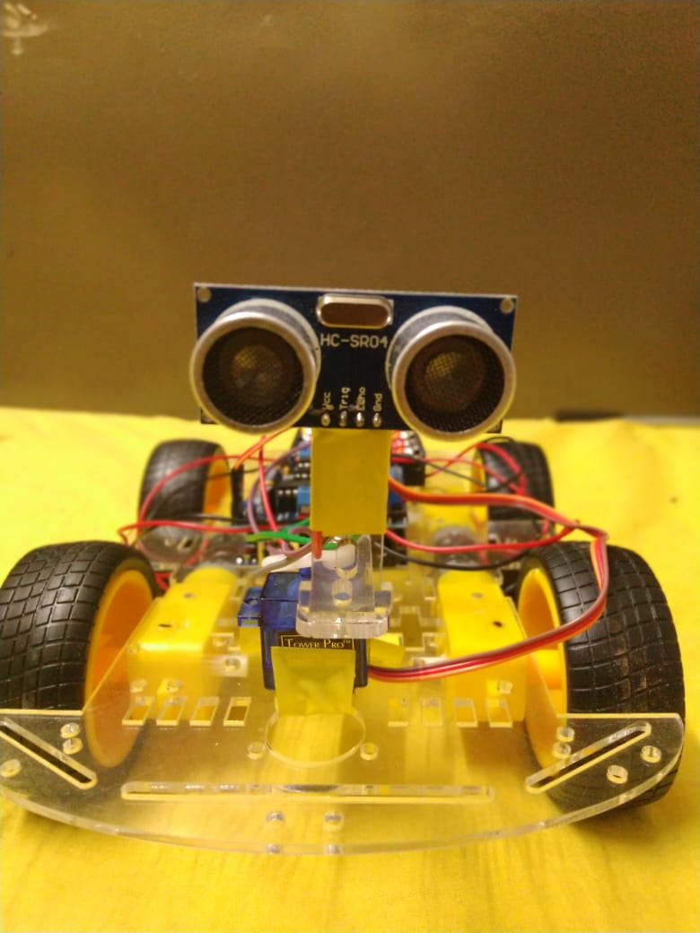

**4.CONCLUSION**

We build a robotic vehicle which moves in different directions like Forward, Backward, Left, and Right when input is given to it. The goal of our project is to create an autonomous robot which intelligently detects the obstacle in his path and navigate according to the actions that we set for it.

**5.FUTURE ENHANCEMETS**

We can further implement more features, such as “obstacle scanning” which can be useful mainly for military purposes.

We can use obstacle avoiding cars to prevents accidents and prevent drivers from drinking and driving.

**6.BIBILOGRAPHY**

This project would not be possible without the the following references and the continued support of our teachers

1.Obstacle avoidance robotic vehicle using ultrasonic sensors for obstacle detection: http://www.elprocus.com/obstacle-avoidancerobotic-vehicle/

2.How to build an obstacle avoiding robot:

https://www.youtube.com/watch?v=JZ5JjvfY1Eg

3.Complete guide for Ultrasonic sensor HC-SR04 Tutorials: http://randomnerdtutorials.com/complete-guide-forultrasonic-ssensor-hc-sr04/